Systematic Disorder:
Russian Culture Under Neoliberalism
Organized by Daria Ezerova (Cambridge) and Mark Lipovetsky (Columbia)

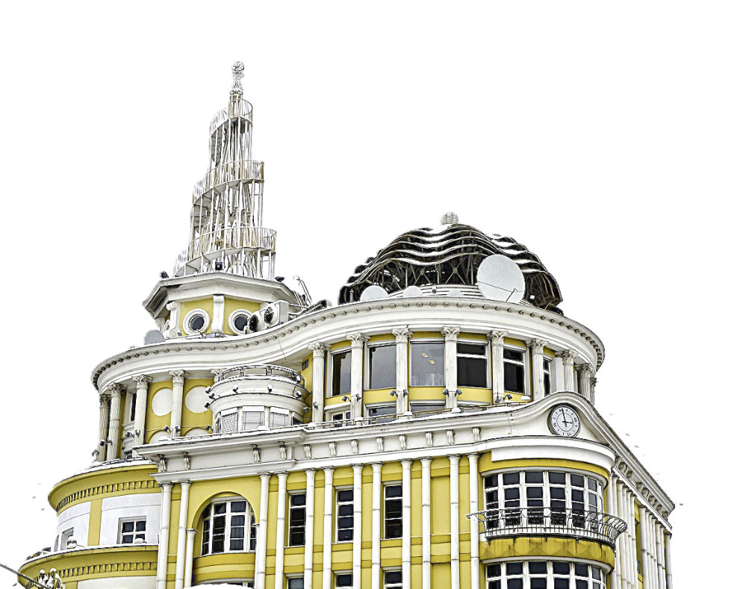

THURSDAY
September 24

International Affairs Building, 12th floor, Harriman Institute’s Atrium

6:00 pm - 7:30 pm. Discussion of the book Russia’s New Imperialism: Capital and Ideology (Stanford University Press, 2026) by Ilya Budraitskis and Ilya Matveev.
Nancy Condee (University of Pittsburgh) in conversation with Ilya Budraitskis and Ilya Matveev (via Zoom).

7:30 - OPENING RECEPTION

FRIDAY
September 25

Calder Lounge, Uris Hall 107, Columbia University, 3022 Broadway

9:00 - 9:30 am. Breakfast

9:30 - 9:45 am. Opening remarks. Daria Ezerova (Cambridge)

9:45 am - 11:45 pm. Panel 1: Late Socialism
Chair: Yana Skorobogatov (Columbia)
Kevin M.F. Platt (Penn). On Making Literature, Making Waves, and Making Money: Soviet Authors between Non-Conformism and Capitalism.
Zachary Hicks (Princeton). Objective Form and the Time of Late Socialism: Late Soviet Cinema and the Making of the Neoliberal Present.
Jinyi Chu (Yale). Startup, Soviet Style: Reimagining Cooperatives During Perestroika.
Juliane Fürst (CEU/ZZF, Potsdam). When Homo Sovieticus Became Adventurous: The Perestroika Press and its Creation of the Delovoi Chelovek.

11:45-12:00 Coffee break

12:00-1:30 pm. Panel 2: Institutions
Chair: Hringur Asgeir Sigurdarson (Columbia)
Eva Ivanilova (University of Pittsburgh). Indigeneity and Capital in Post-Soviet Russia.
Margarita Kuleva (NYU). Building a Stateless Oasis: Workers of Russian Private Cultural Institutions Between Grassroots Neoliberalism and Governmental Control.
Vlad Strukov (University of Leeds). Neoliberal Utopia: Museums (of Contemporary Art) as Ideologues of Extractivism and Militarism.
1:30-2:45 pm. Lunch at the Harriman Institute’s Atrium

2:45 - 4:45 pm. Panel 3: Gender and Care
Chair: Tatiana Krasilnikova (Columbia)
Alexey Golubev (University of Houston). Before Neoliberalism: Medical Literacy and the Technocratic Turn in Late Soviet Society.
Victoria Buyanovskaya (Dickinson College). Learned Helplessness: Neoliberalism, the Crisis of Care, and Caring Narratives in Oksana Vasyakina's Steppe.
Elena Gapova (Western Michigan University). The Feminism of Our Discontent: On Sex, (mis)Trust, and Contract.
Lilya Kaganovsky (UCLA). Post-Soviet Feminism Between State Socialism and Global Neoliberalism.

4:45-5:00 pm. Coffee break

5:00 - 6:30 pm. Keynote address
Masha Salazkina (Concordia University). “A Band from the Caribbean Islands”: Boney M and the Global Popular Imagination of Late Socialism.
Moderated by Mark Lipovetsky (Columbia).

7:30 pm. DINNER

SATURDAY
September 26

9:00-9:30 am. Breakfast

9:30 - 11:00 am. Panel 4: Patriotic Culture Industry
Chair: Aleksandar Momcilovic (Columbia)
Eliot Borenstein (NYU). Even Neoliberals Get the Blues: Post-Soviet Melancholy for the Masses.
Oleg Kashirskikh (Weizenbaum Institute, Berlin); Jeremy Morris (Aarhus University). The Cultural Production of Wartime Normality: Authoritarian Neoliberalism as a Regime of Truth in Contemporary Russia.
Michał Murawski (University College London). From Culture Tree to Culture Z: Russian architecture in the age of authoritarian neoliberalism.

11:00 – 11:15 am. Coffee break

11:15 am - 12:45 pm. Panel 5: Literature and Theatre
Chair: Konstantin Mitroshenkov (Columbia)
Bradley Gorski (Georgetown University). Neoliberal Irreality.
Edward Tyerman (UC-Berkeley). Eternal Crisis of the Peripheral Empire: Vladimir Sorokin’s World System.
Natalia Plagmann (Middlebury College). Stages of Labor: Dreamworlds, Struggles, and Experiments of Russian Theatre in Neoliberal Times.

12:45 - 1:30 pm. Lunch

1:30 - 3:00 pm. Panel 6: Contemporary Art
Chair: Liza Senatorova (Columbia)
Klavdia Smola (Technische Universität Dresden). The Double Bind of Dissent: Reimagining the Soviet Left under Russian Authoritarian Neoliberalism.
Maksim Hanukai (University of Wisconsin-Madison). Curing Capitalism: The Conceptualist Pharmacy in the Time of Transition.
Nora Furlong (Oxford). Ultranationalist Art and an Ostensibly Ironic Audience: Alexey Belyaev-Gintovt and the Politics of Post-Soviet Aesthetics.

3:00-3:15 pm. Coffee break

3:15 - 5:15 pm. Panel 7: Popular Culture
Chair: Nathan Goldstone (Columbia)
Ilya Kalinin (Humboldt University, Berlin). The Neoliberal Time Loop: From the Privatization of the Past to the Monopolization of the Future.
Zachary Murphy King (Bilkent University). In Media Res: Santa Barbara and the Cultural Translation of Neoliberalism in the Post-Soviet World.
Tatiana Efremova (The George Washington University). Shortparis and the Post-Soviet (Re)Creative Class.
Marijeta Bozovic (Yale). Hacking Democracy: Russian Hackers as Myth and Machine.

5:15-5:30 pm. Coffee break

5:30 - 7:00 pm. Panel 8: Neoliberal Dialectics
Chair: Adam Leeds (Columbia)
Marina F. Bykova (North Carolina State University). Neoliberalism and the Transformation of Russian Philosophical Culture.
Artemi Magun (Bard College). Neoliberalism? Really?
Keti Chukhrov (Academy of Fine Arts, Stuttgart). Can Post-Socialist Techno-Feudalism Be Neoliberal?

Keynote: Masha Salazkina. "A Band from the Caribbean Islands“: Boney M and the Global Popular Imagination of Late Socialism.

Boney M — a West German-produced disco group of Caribbean performers whose hits "Rivers of Babylon," "Rasputin," "Sunny" and "Daddy Cool" made them one of the most widely heard acts in the world in the late 1970s and 1980s — were almost entirely unknown in the United States. Everywhere else, they were inescapable; in the Soviet Union in particular, their music permeated daily life from youth discotheques and kitchen radios to the soundtracks of feature films. This talk argues that this ubiquity constitutes a privileged site for thinking about the cultural prehistory of Russian neoliberalism. Officially sanctioned and enthusiastically consumed, Boney M were simultaneously apolitical and transgressive, postcolonial and commercial, and collectively euphoric and saturated with the imagery of individual freedom: a global popular culture already projecting the aspirational subject positions that would define the neoliberal era. Their Soviet acceptance required productive misreadings — ideological alibis that reframed their music as anti-colonial solidarity, European light entertainment, or harmless fun — yet produced real affective formations, consumer desires, and social practices that exceeded any institution's intentions. Tracing Boney M’s reception across the (post)socialist world from the 1978 Moscow concerts to the barter economies of the Eastern European circuit, from Vietnamese wedding traditions to post-Soviet oligarchic entertainment culture, the talk asks what this history reveals about the ambivalent politics of popular pleasure: its capacity to function simultaneously as accommodation and as a form of excess no ideological alibi could fully contain.

Masha Salazkina is Professor of Film and Moving Image Studies at Concordia University, Montreal. She is the author, most recently, of World Socialist Cinema: Alliances, Affinities, and Solidarities in the Global Cold War (winner of the ASEEES/USC Book Prize, 2024) and Romancing Yesenia: How a Mexican Melodrama Shaped Global Popular Culture (winner of the Wayne S. Vucinich Book Prize, 2024), and the co-editor of five scholarly volumes on topics ranging from sound studies to amateur cinema to teaching migration. Her most recently published volume, Global Solidarities in Film Culture: Conversations (Meson Press, 2026) draws on interviews with leading film scholars, curators, and archivists to open onto a broader interrogation of solidarity-building through practices of working with moving image media, its multivalent histories, and contemporary resonances. She is currently finishing, with Usha Iyer, a book on the global popularity of Boney M, and working on a new book project on the circulation of Latin American telenovelas in the (post)socialist world.

